Lab 1 Report: Requirements Elicitation & Modeling (QuickShip)
Title: Elicitation and Modeling Requirements for the QuickShip Delivery Platform
Course Info: Software Architecture
Group: 11
Student Details: Nguyen Trong Thai – 23010457
Nguyen Minh Quang - 23010419
Date: December 6, 2025

2. Abstract/Summary
The QuickShip project aims to design a modern parcel delivery and tracking platform. This lab focused on requirements elicitation and modeling, documenting Functional, Non-Functional, and Architecturally Significant Requirements (ASRs). A UML Use Case Diagram was developed to define system boundaries, external actors, and primary user interactions. These foundational requirements will guide the architectural design and separation of concerns in the next lab (Layered Architecture).

3. Lab Specific Section: I. Requirements Elicitation & Modeling

3.1 Software Requirements Specifications (SRS)

3.1.1 Functional Requirements (FRs)
ID | Description | Priority
FR-01 | The system must allow a Customer to create new delivery orders with sender and receiver details. | High
FR-02 | The system must allow a Customer to track shipment status in real-time. | Critical
FR-03 | The system must allow a Shipper to accept and update delivery progress. | High
FR-04 | The system must send automatic notifications for each delivery status change (e.g., Picked Up, Delivered). | Medium
FR-05 | The system must allow an Admin to manage users, shipments, and delivery records. | High

3.1.2 Non-Functional Requirements (NFRs)
ID | Attribute | Description | Impact
NFR-01 | Performance | The system must support 5,000 concurrent users with 95% of requests under 3 seconds response time. | High
NFR-02 | Security | All communication and data storage must use encryption (TLS 1.3, AES-256). Sensitive shipment data must be protected. | Critical
NFR-03 | Availability | System uptime must be at least 99.8% with auto-restart and failover for delivery tracking services. | Critical
NFR-04 | Usability | Mobile app and web portal must provide an intuitive and responsive interface for customers and shippers. | Medium

3.1.3 Architecturally Significant Requirements (ASRs)
ASR ID | Quality Attribute | Requirement Statement | Architectural Rationale
ASR-01 | Scalability | System must handle increasing delivery traffic during high-demand periods (e.g., holiday season) without degradation. | Requires adoption of distributed services, load balancing, and message queues (e.g., RabbitMQ, Kafka).
ASR-02 | Security | All shipper and customer actions must be authenticated with role-based authorization. | Enforces access control in the Business Logic layer to protect shipment data and operations.
ASR-03 | Availability | Delivery tracking must remain functional during network or server failures. | Requires redundant servers, health checks, and auto-failover mechanisms for tracking microservices.

3.2 Modeling Artifact: UML Use Case Diagram
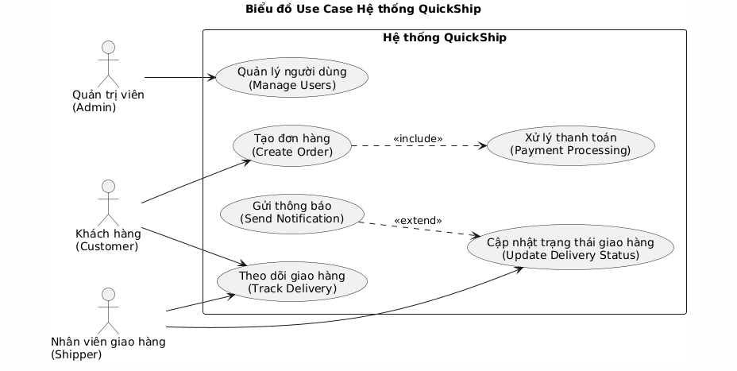

4. Architectural Design (Next Lab – Problem Analysis)

4.1 Problem Statement
The goal is to design a scalable and fault-tolerant architecture for QuickShip that supports continuous operation, secure communication, and modular service updates. A Layered Architecture pattern is proposed to ensure separation of concerns and reliability across the system.

4.2 Impact of ASRs on Architectural Design
• ASR-01 (Scalability): Encourages distributed deployment and scaling of delivery and tracking services.
• ASR-02 (Security): Access control logic and authentication implemented within the Business Logic Layer.
• ASR-03 (Availability): Requires redundant tracking servers and failover mechanisms.

5. Conclusion & Reflection
The elicitation and modeling phase for QuickShip successfully captured the system’s goals and behaviors. Functional and Non-Functional Requirements define what the system must do and how it must perform. The ASRs highlight essential architectural drivers like Scalability, Security, and Availability, which will guide the Layered Architecture design in Lab 2 to ensure continuous delivery tracking and a robust user experience.

